Create a local "repository" with project name cloudethix_devops_yourname with
a git tool.

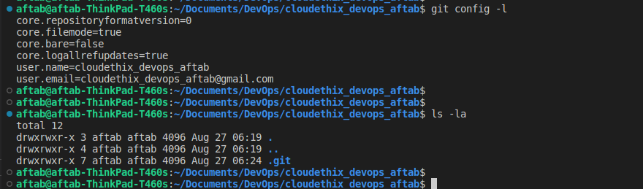

Create 3 files named hello.txt , world.txt ,cloudethix.txt. Add some data in the
files. Then add those files to the staging area. And then commit those to your
local repository.

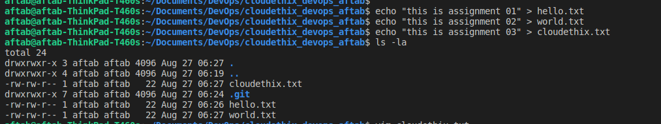
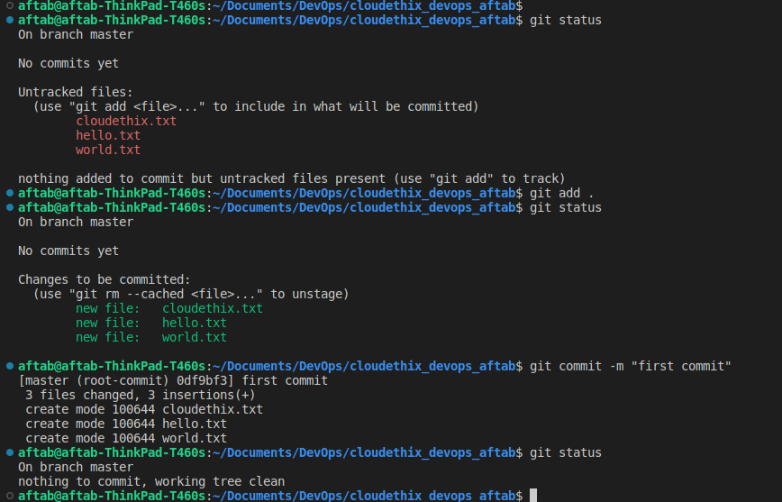

3. Delete cloudethix.txt file from your system and recover it with git.

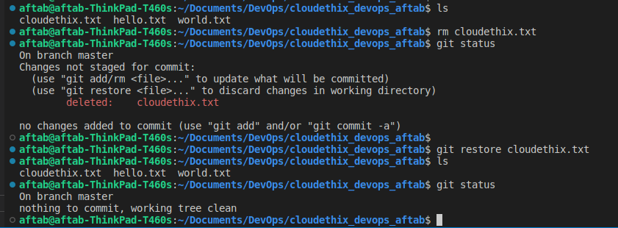

4. Create 4 branches with GIT develop, release, hotfix , feature.

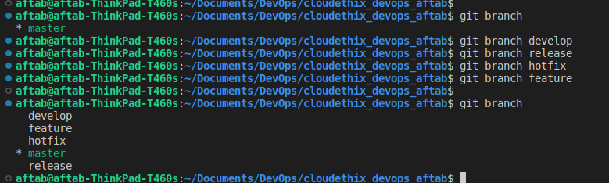

5. Prove that data in branch develop and release branch is not the same by
committing some files to both the branches.

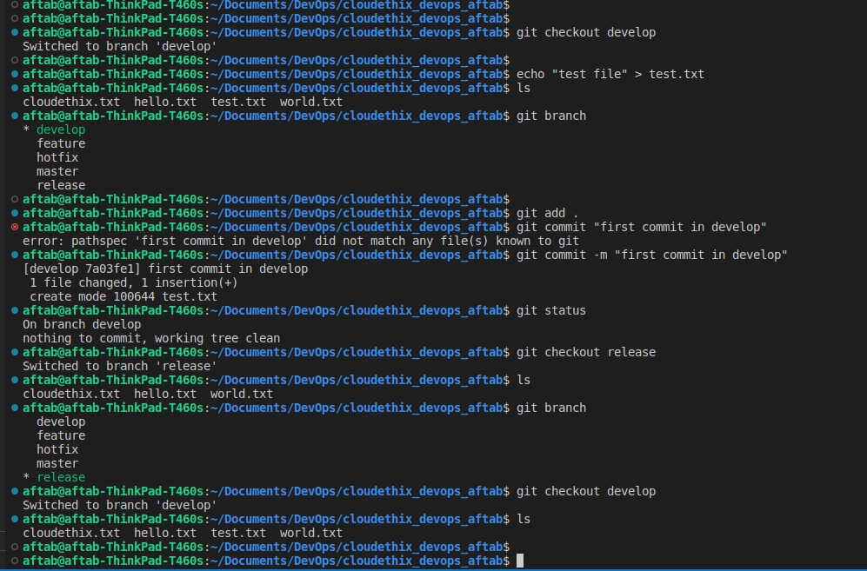

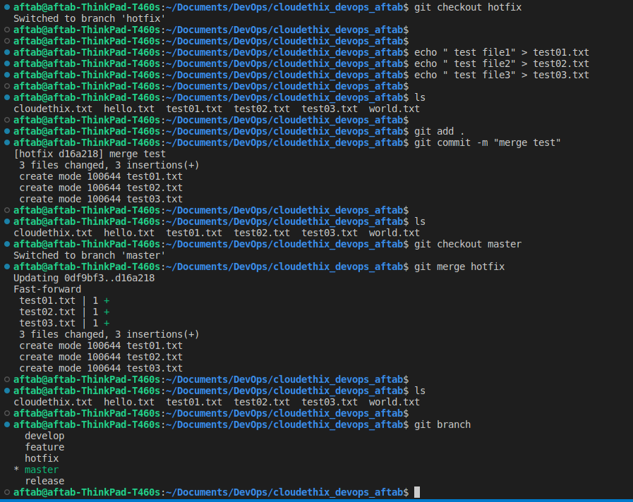
6. Add any 3 files to the hotfix branch and merge the hotfix branch with master
branch.

7. Once a hotfix branch is merged , check the logs and then delete the hotfix
branch.

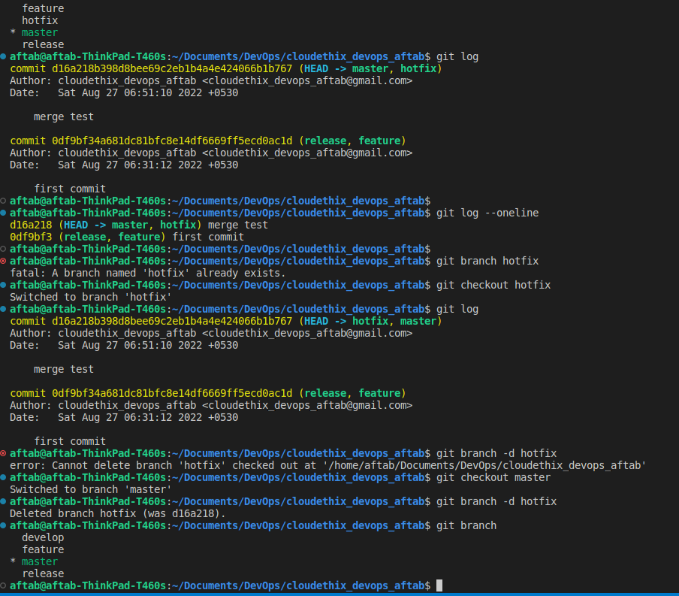

8. Create one repository to GITHUB then push your master branch to the remote
repository.

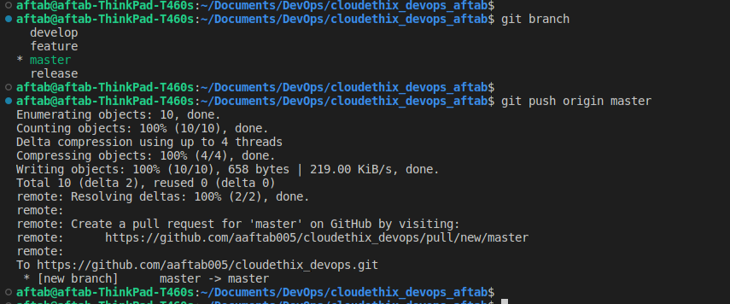
9. Clone the remote repository to your local system and then create any 3
directories in the repository. Then create 3 files in each directory. Then commit
the changes to the remote repository.

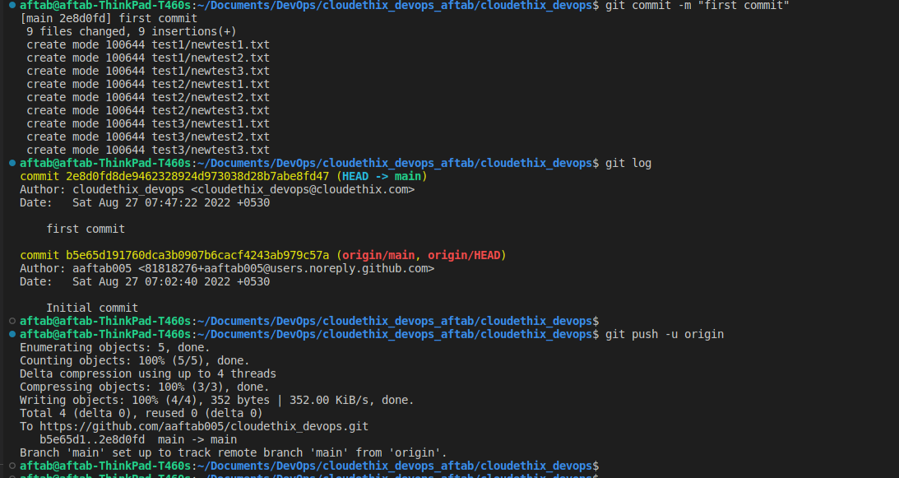

10. Create a new branch to the cloned remote repository, add some more files ,
commit and push the new branch to the remote repository.

